ASSIGNMENT 1
- Provide the Python code in GitHub and share the GitHub link as a submission.
- Provide brief documentation on the steps followed.
- Take a screenshot of the steps and put them into the documentation.
Evaluation Criteria:
- Correctness of the code.
- The ability to complete the task.
- Clarity and organization of documentation.
You are only required to do any 4 of the below for the grading. However, it is recommended that you practice as much as possible, which will help you build your expertise with automation and various AWS services.
Tasks:
Assignment 1: Automated Instance Management Using AWS Lambda and Boto3
Objective: In this assignment, you will gain hands-on experience with AWS Lambda and Boto3, Amazon's SDK for Python. You will create a Lambda function that will automatically manage EC2 instances based on their tags.
Task: You're tasked to automate the stopping and starting of EC2 instances based on tags. Specifically:
1. Setup:
- Create two EC2 instances.
- Tag one of them as `Auto-Stop` and the other as `Auto-Start`.
2. Lambda Function Creation:
- Set up an AWS Lambda function.
- Ensure that the Lambda function has the necessary IAM permissions to describe, stop, and start EC2 instances.
3. Coding:
- Using Boto3 in the Lambda function:
- Detect all EC2 instances with the `Auto-Stop` tag and stop them.
- Detect all EC2 instances with the `Auto-Start` tag and start them.
4. Testing:
- Manually invoke the Lambda function.
- Confirm that the instance tagged `Auto-Stop` stops and the one tagged `Auto-Start` starts.
Instructions:
1. EC2 Setup:
- Navigate to the EC2 dashboard and create two new t2.micro instances (or any other available free-tier type).
- Tag the first instance with a key `Action` and value `Auto-Stop`.
- Tag the second instance with a key `Action` and value `Auto-Start`.
2. Lambda IAM Role:
- In the IAM dashboard, create a new role for Lambda.
- Attach the `AmazonEC2FullAccess` policy to this role. (Note: In a real-world scenario, you would want to limit permissions for better security.)
3. Lambda Function:
- Navigate to the Lambda dashboard and create a new function.
- Choose Python 3.x as the runtime.
- Assign the IAM role created in the previous step.
- Write the Boto3 Python script to:
1. Initialize a boto3 EC2 client.
2. Describe instances with `Auto-Stop` and `Auto-Start` tags.
3. Stop the `Auto-Stop` instances and start the `Auto-Start` instances.
4. Print instance IDs that were affected for logging purposes.
4. Manual Invocation:
- After saving your function, manually trigger it.
- Go to the EC2 dashboard and confirm that the instances' states have changed according to their tags.
created a 2 t3.micro instance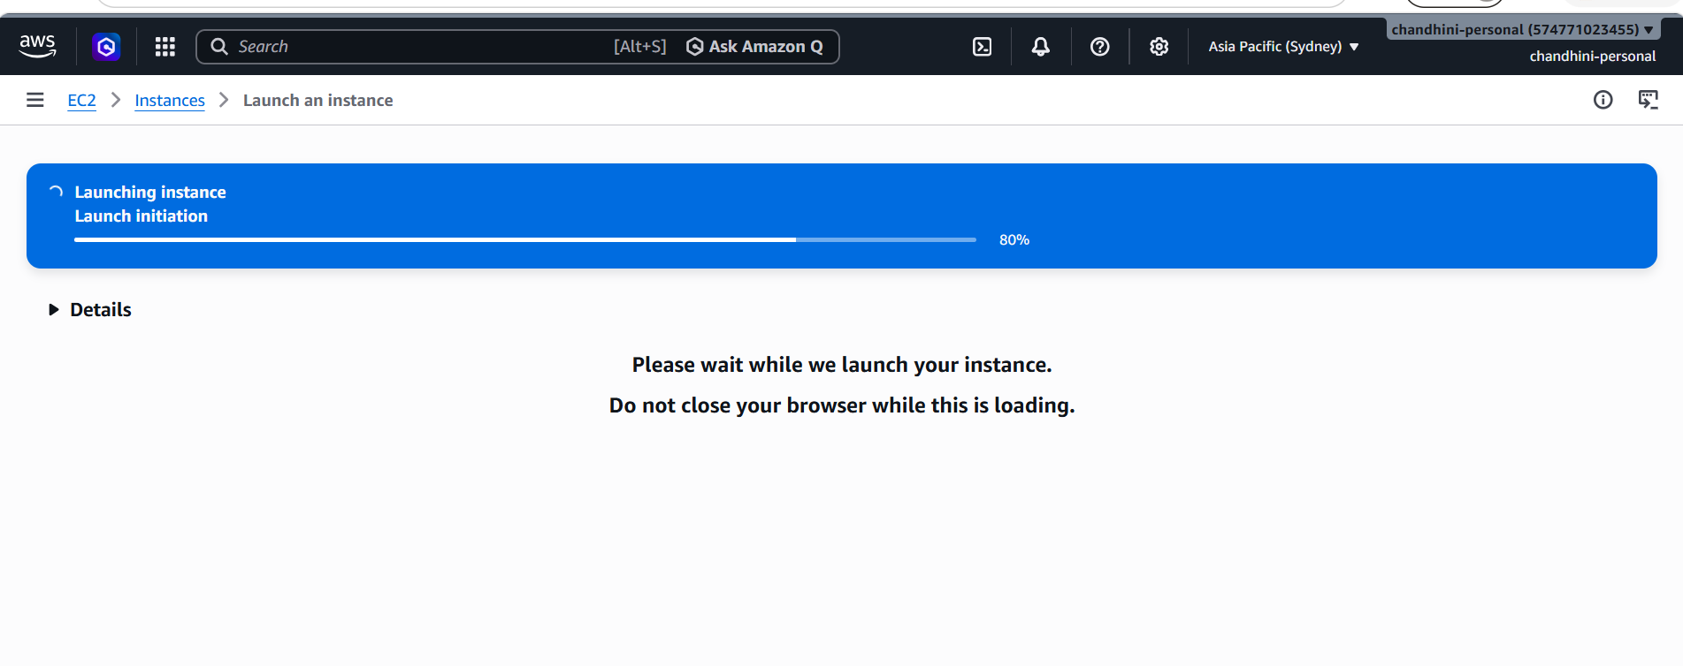

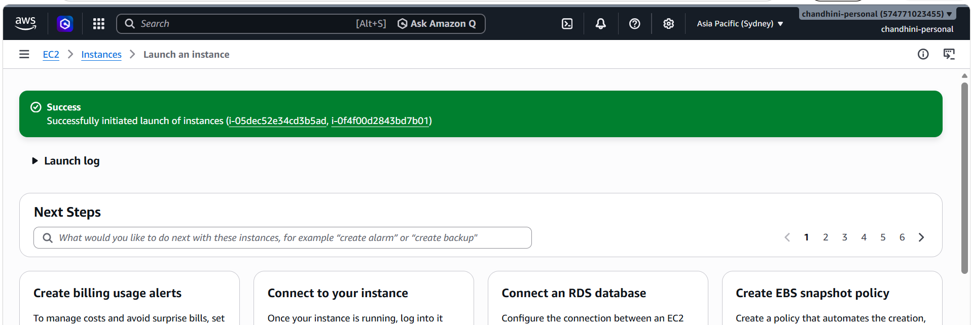
Add tags for both instances as Auto-Stop & Auto-Start
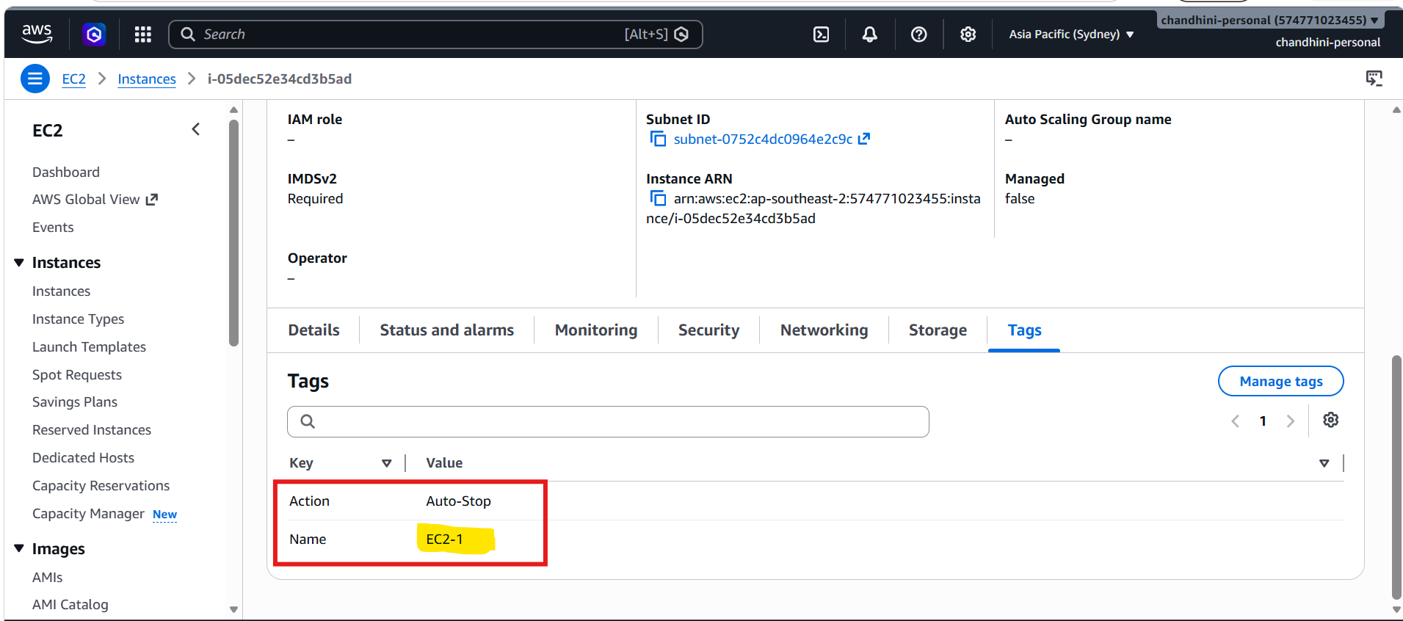
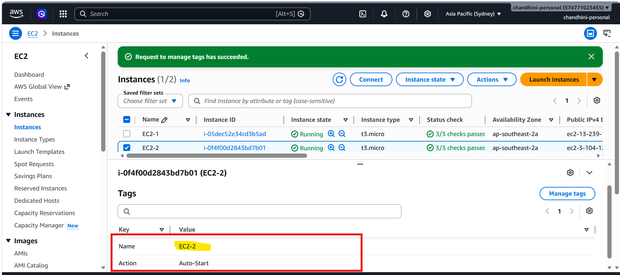

Creating IAM ROLE FOR LAMBDA TO HAVE FULL ACCESS ON EC2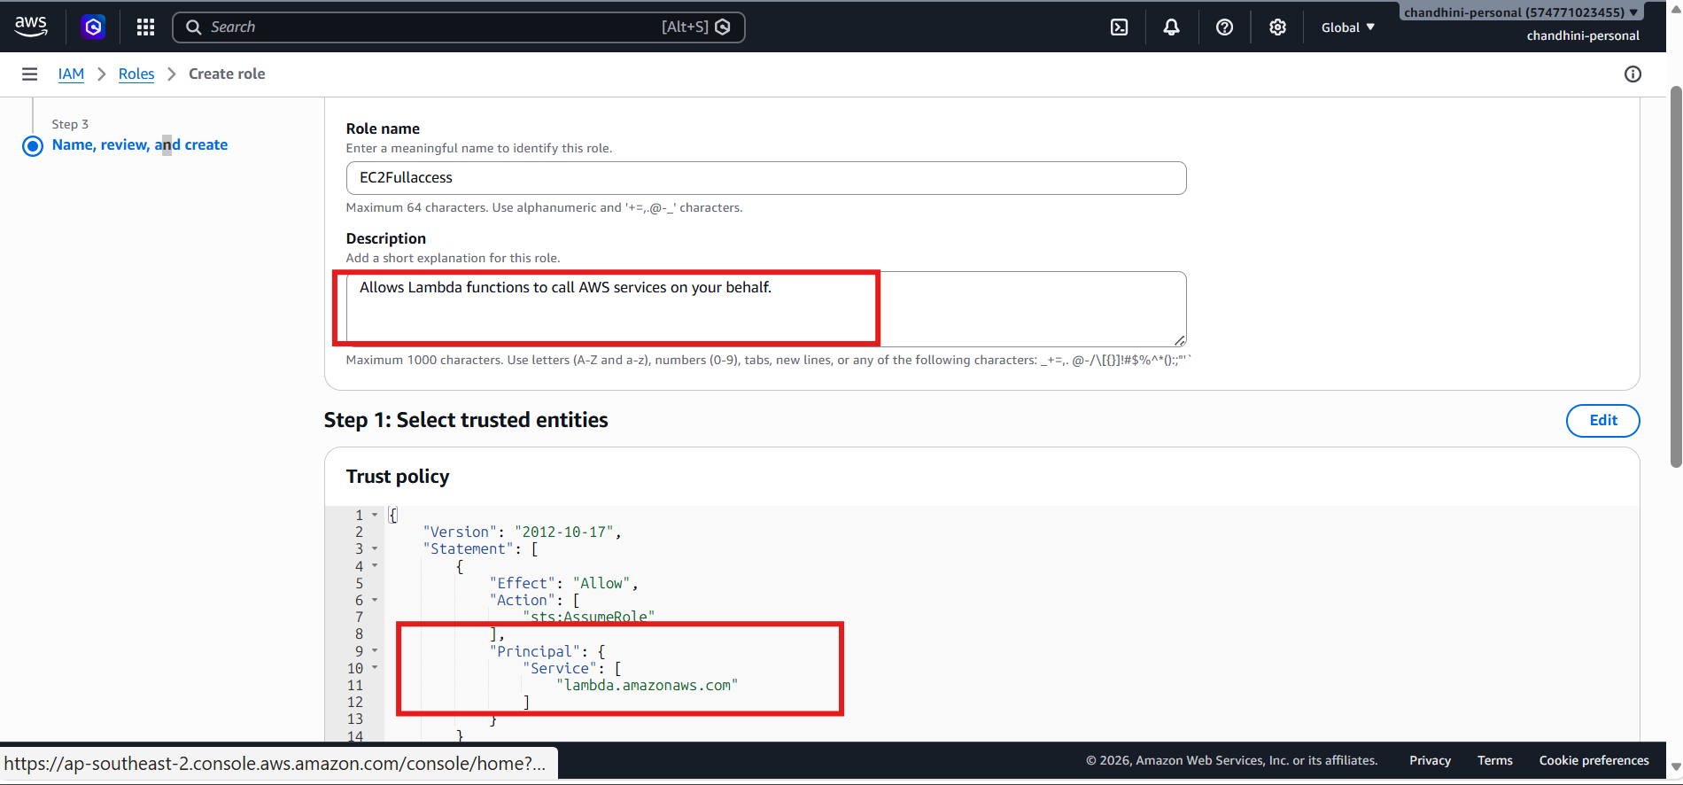
Note: In a real-world scenario, you would want to limit permissions for better security.

Wrote the below boto3 code, tested and deployed and saved it
import boto3

# Initialize EC2 client
ec2 = boto3.client('ec2')

def lambda_handler(event, context):

response = ec2.describe_instances(
Filters=[
{
'Name': 'tag-key',
'Values': ['Action']
}
]
)

auto_stop_instances = []
auto_start_instances = []

for reservation in response['Reservations']:
for instance in reservation['Instances']:
instance_id = instance['InstanceId']

for tag in instance.get('Tags', []):
if tag['Key'] == 'Action' and tag['Value'] == 'Auto-Stop':
auto_stop_instances.append(instance_id)

elif tag['Key'] == 'Action' and tag['Value'] == 'Auto-Start':
auto_start_instances.append(instance_id)

# Stop instances tagged Auto-Stop
if auto_stop_instances:
ec2.stop_instances(
InstanceIds=auto_stop_instances
)
print(f"Stopped Instances: {auto_stop_instances}")

# Start instances tagged Auto-Start
if auto_start_instances:
ec2.start_instances(
InstanceIds=auto_start_instances
)
print(f"Started Instances: {auto_start_instances}")

return {
"statusCode": 200,
"stopped_instances": auto_stop_instances,
"started_instances": auto_start_instances
}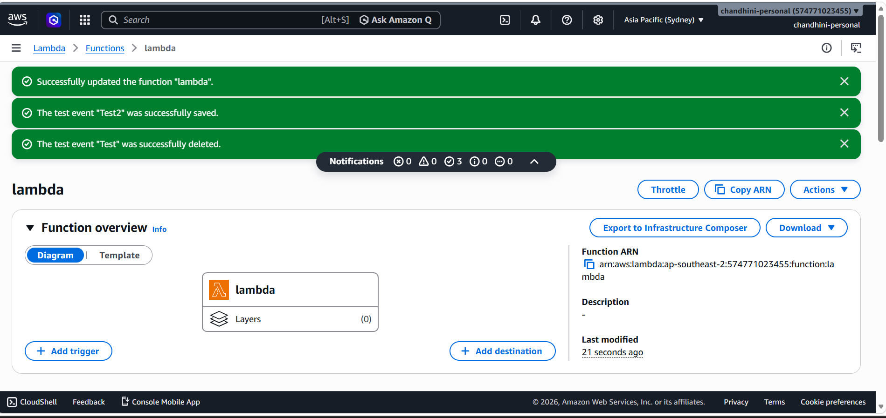

Post while testing the final run ,got the expected output
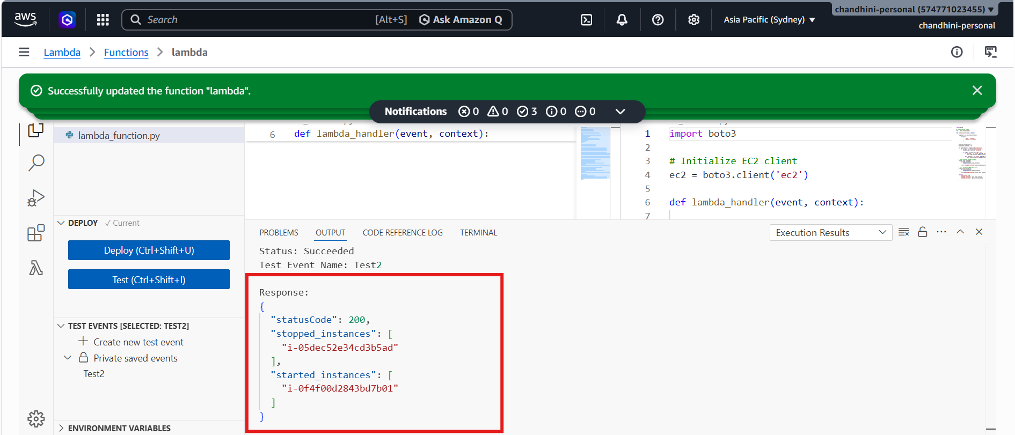
FROM EC2 Instance dashboard page
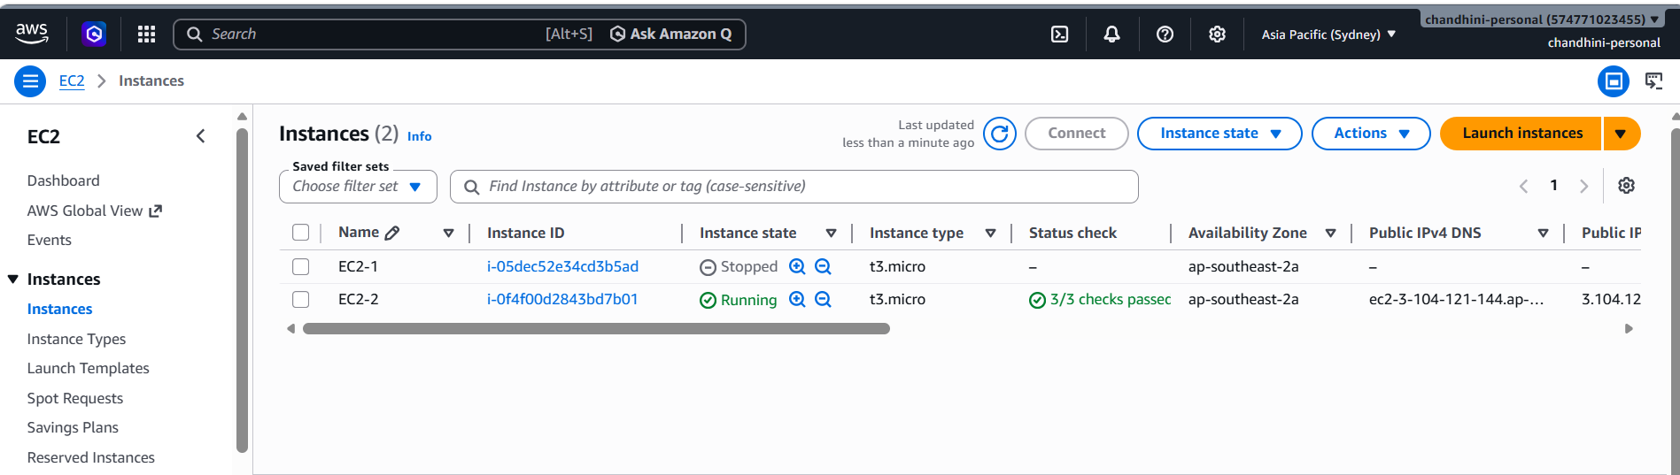
Tried checking in Cloudwatch ,but wasnot able to as in monitor I could see below pop up message in blue box
Missing permissions
Your function doesn't have permission to write to Amazon CloudWatch Logs. To view logs, add the AWSLambdaBasicExecutionRole managed policy to its execution role. Open the IAM console
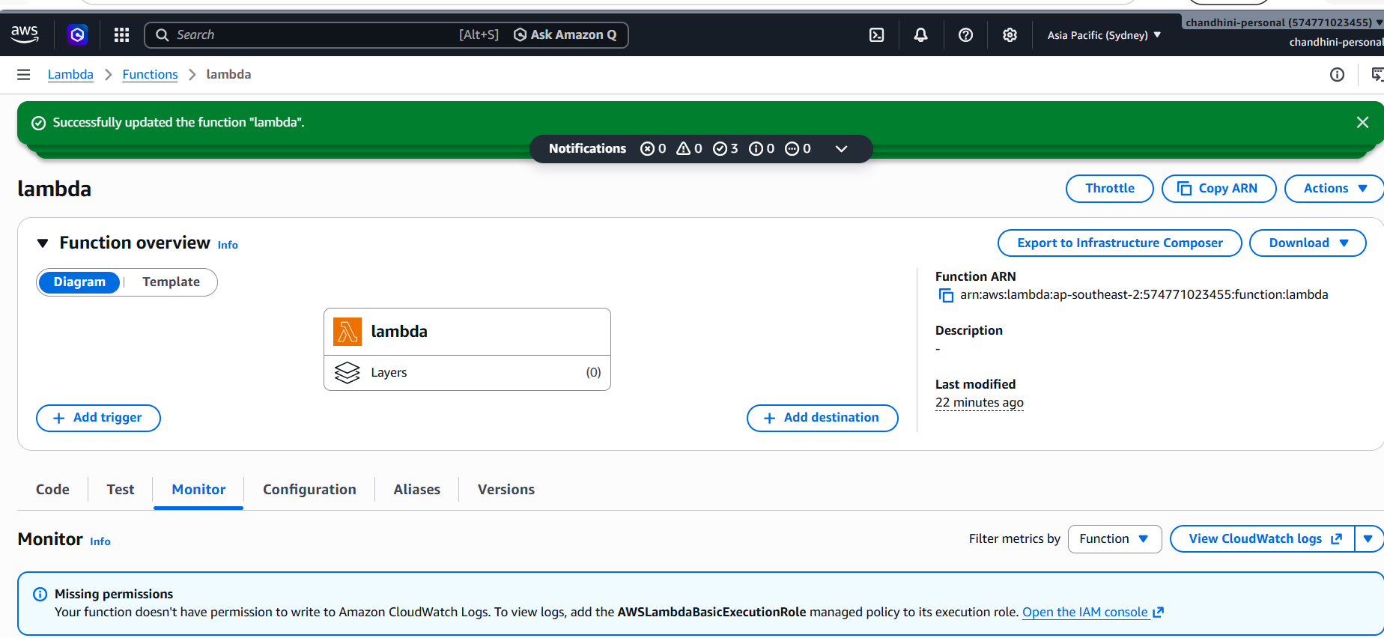
And followed below steps to add the permission and attach policy
Step 1: Find the Lambda Execution Role
Open your Lambda function.
Go to Configuration → Permissions.
Under Execution role, click the role name.
Step 2: Add CloudWatch Logging Permissions
In IAM, click Add permissions → Attach policies.
Search for:
AWSLambdaBasicExecutionRole
Select it and attach it.

This policy grants:
{
"logs:CreateLogGroup",
"logs:CreateLogStream",
"logs:PutLogEvents"
}
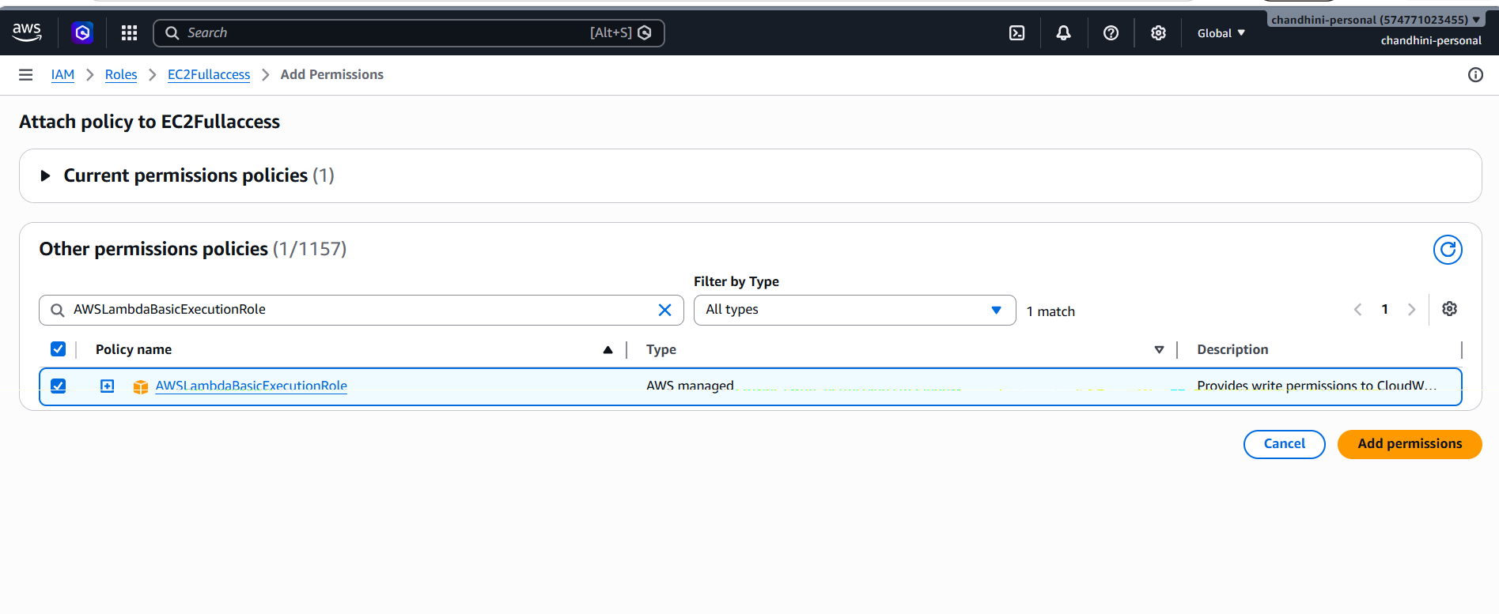
Again tested lambda function and got the logs generated in cloud watch
Below is step followed to reach the Navigatable cloud watch URL
In Lambda FunctionFunction nameMonitor Cloudwatch URL LogManagementLog events
